1. **Task Description:-**

In this task, I created a **Dynamic Form using React** that enables users to add multiple input fields dynamically by clicking a button. Each field allows the user to enter text, and upon submitting the form, all the entered data is displayed on the same page.

1. **Task Output Screenshots:-**
   1. Home Page

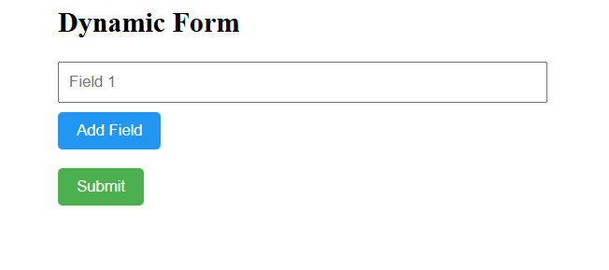

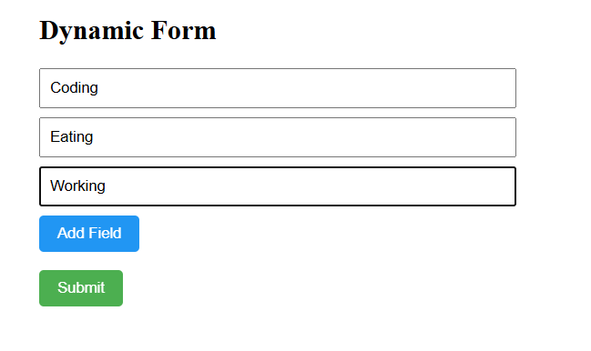

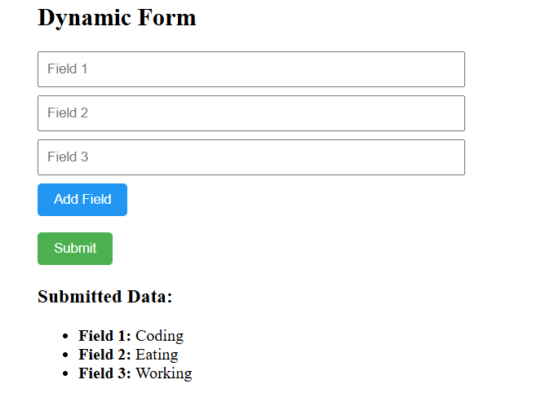

1. **Widget/Algorithm Used in Task:-**
   1. **useState:-** Used to manage two states in the dynamic form:
      1. The array of dynamic input fields (fields)
      2. The array that stores submitted data (submittedData)
   2. **UUID**:- A library used to generate **unique IDs** for each input field so that React can efficiently render, update, and track each field individually.
   3. **handleAddField:** Adds a new input field with a unique ID and an empty value to the fields array.
   4. **handleChange:** Updates the value of a specific input field when the user types in it.
   5. **handleSubmit:** Prevents the default form submission behavior, saves the entered data to the submitted data array, and clears the input fields for new entries.